**Lane Detection and Turn Prediction**

**ENPM673 P2 report**

**Yash Manian**

The pipeline for this problem is as follows:

**Denoise the image** –

Before performing any mathematical analysis on the image, it is important to smooth out the high frequency noise in the image. I used a Gaussian kernel to smooth out the noise before processing.

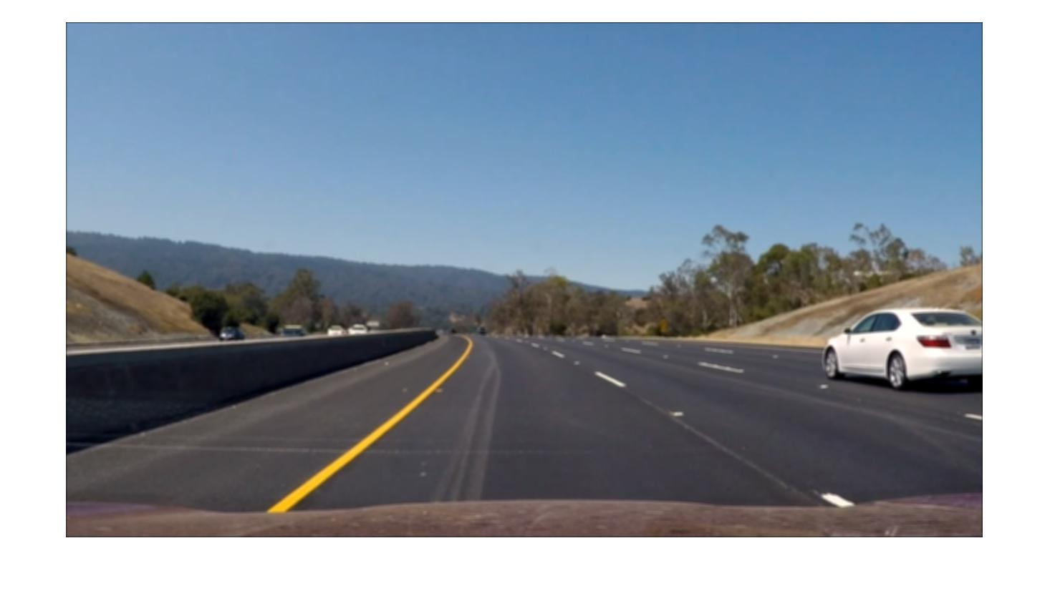

**Detect edges** –

I used a correlation filter to detect lines with gradients varying from -1 to 1. The filter works better than the Canny and Sobel filters. This was found at the following link:

<https://www.mathworks.com/help/vision/examples/lane-departure-warning-system.html>

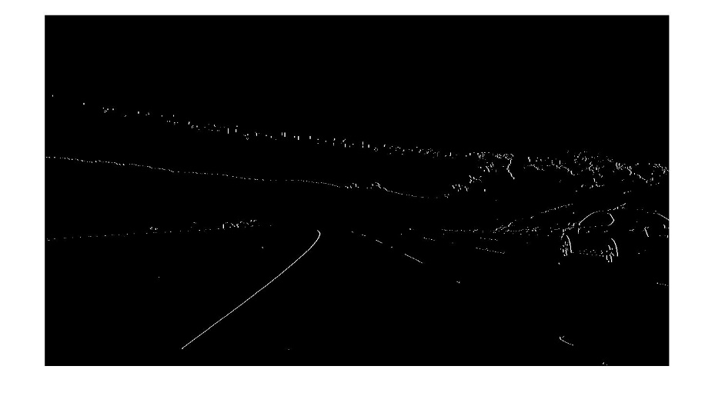

**Masking the image**-

A trapezoidal mask was used to mask out the sides of the road, and the top half of the frame. This helps the algorithm to get rid of unnecessary edges, and focus on the lanes on the road. This also significantly reduces computation time, as the area of the image over which floating point operations are carried out is reduced.

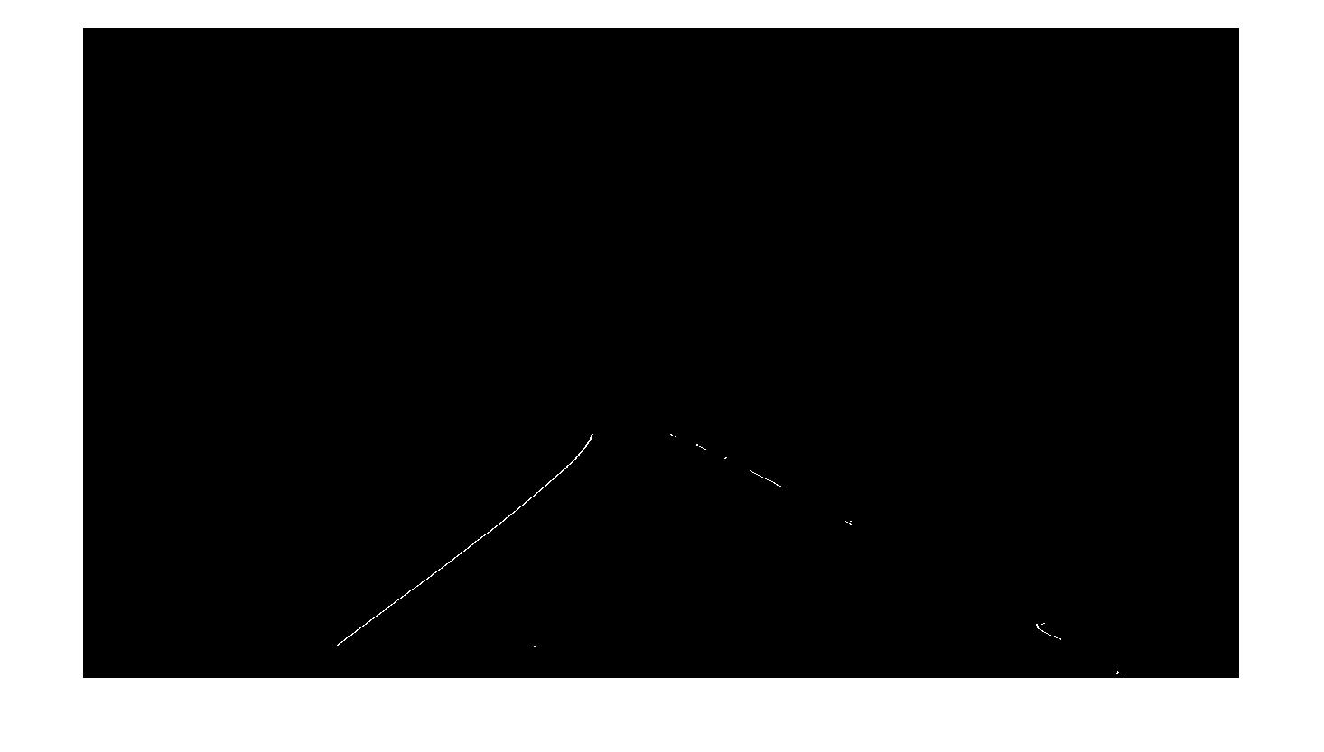

**Applying the Hough transform**-

I then applied the Hough transform to the frame. Hough lines were found using the Hough peaks for the rho and theta values. The best set of parameters for this was determined through experimenting. The lines are classified as the left lane or the right lane based on the slopes of the Hough lines. These Hough lines are stored in structures in MATLAB. Due to the nature of MATLAB, these structures don’t get cleared at the end of every iteration, and hence need to be manually cleared.

These lines are then classified as the left and right lanes based on their slopes.

**Spline fitting and Turn Prediction** -

The start and end points of the left and right lines are stored. These are then used

to fit a line to the points to get the lanes. To account for the curves in the lanes, a set of three points was used to fit the spline. The points used for fitting this curve are the starting points, ending points and the vanishing point for the two lines in the image.

The turn is predicted based on the position of the vanishing point of the two lanes. After experimentation a range was determined for the vanishing point, where the lanes were visibly straight. Based on the motion of the vanishing points to the right or left of the threshold, the turn can be predicted.

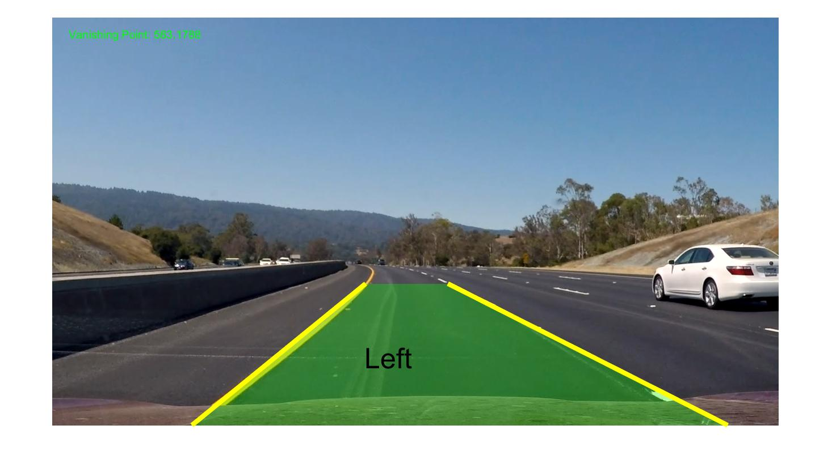

**Extra Credit Challenge Video**

The pipeline for the extra credit is relatively the same. However, problems arise due to the coloration

of the road, which leads to an extra line being detected between the left and right lanes. To solve this,

the thresholding parameters for the edge detector were tweaked to obtain the yellow and white lanes

in the frames.

